Keene, Donald John
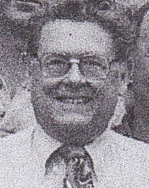
Graduated from Australian Forestry School in 1962. Commenced work as an Assistant Divisional Forests Officer in 1963. Spent some time at Shannon River in 1960s. Transferred to Busselton 1969. At Busselton in the early1970s. Transferred from Busselton to Kirup in 1972. Superintendent at Manjimup in early 1980s. Acting Chief of Division then promoted to that position in Perth in mid 1980s. CALM Director of Forests in early 1990s. Retired in 2000. Part owner of a race horse.

